Salesforce announces Nonprofit Cloud
Standing true to Salesforce’s 1-1-1 model where 1% is pledged for community, the announcement of Nonprofit Cloud is one more step in the way of giving back to the community. It aims to equip nonprofits with a complete solution set to track and measure programs in real time, raise more funds by unlocking data with AI driven insights and take every constituent on their own personal journey, from onboarding to impact. The announcement was made by Salesforce on June 13,2018 during Connections in Chicago.
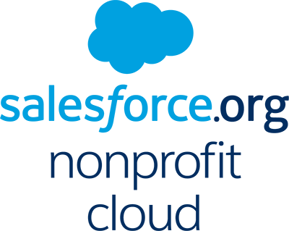

Nonprofit Cloud Overview:
Nonprofit cloud comprises of the following components currently:
Nonprofit Success Packs (NPSP)- The Nonprofit Success Pack starts with a flexible, open data architecture and adds pre-built constituent and donor management components. The first one, Growth Kit, helps small and medium-sized nonprofits get started with CRM and marketing automation.
Program Management: It will enable nonprofits to save time by quickly spinning up mobile and social apps to manage their programs and services and deliver them in efficient new ways. Program Management come with the following features:
  - Case Management
  - Call Centers and Client Service
  - Program Management
  - Apps

Community Management: It will help in engaging and strengthening the community via collaboration. The coordinated effort among staff, funders, individuals, volunteers and different supporters is critical to building alignment and accelerating towards central goal. change. It has the following features:
  - Social Intranets
  - Member Communities
  - Partner Communities
Marketing Communications: It will enable nonprofits to communicate more effectively and also to communicate with their constituents at the right time with the right message. By implementing correct marketing communication strategies, organizations can dramatically amplify their social change efforts. It has following components to offer:
  - Email Marketing
  - Social Media Engagement
  - Mobile Marketing
  - Lifecycle Automation
Fundraising: This remains the crux for any nonprofit to function. Fundraising module in the Nonprofit cloud will help in Cultivating lifelong relationships and securing the support needed. It will aide in establishing and growing donor relationships as well as in managing the donation cycle from pledge to payment while offering a collaborative, social and mobile experience which today’s donor expect. It has following features to offer:
  - Fundraise
  - Donor Management
  - Grants Management
  - Volunteer Management
  - Events Management
  - NGO Connect
Analytics: Salesforce Wave Analytics will add capabilities to drill into data to identify opportunities and make better decisions. Quick query and data exploration across systems will give access to exact information needed without getting stuck in prebuilt reports. One can also collaborate immediately and share insights with team members right inside Salesforce. Analytics in nonprofit clouds come with following features:
  - Find and Share Answers Instantly
  - Turn Answers into Collective Action
  - Discover Insights from Your Phone
  - Any Data. Any Source

Advantages of Nonprofit Cloud:
With Nonprofit Cloud, nonprofits like yours can:
- Gain a complete view of your constituents and your mission
- Track and measure impact in real time
- Raise more resources by unlocking donor data, and
- Take every constituent on their own personal journey

Pricing and Availability
For more information on pricing and solution Kits, please visit: http://www.salesforce.org/nonprofitcloud

